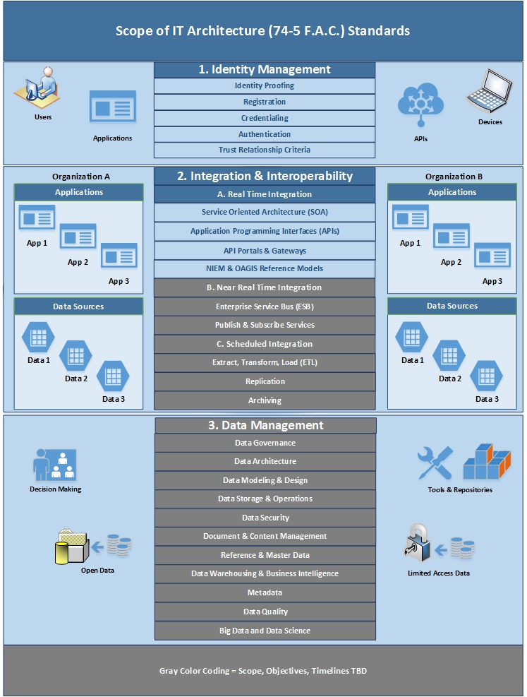

- Identity Management (IDM) Standard (F.A.C. 74-5.001 and 74-5.003) became rule on 8/3/17.
  - Primary goal: Ensure that agencies have secure and interoperable IDM Services.
  - Objectives: Reduce duplicative identity data and identity management services.
  - Inventory Requirement: Catalog of IDM Services and dependent applications.
  - Assessments of IDM Services will occur in 1st half of 2018; Survey & Interview => Gap Analysis.

- Integration Standard Draft finalized October 2017. Rulemaking to be initiated 1st half of 2018.
(Focus for 1st release of Integration Standard is real time integration architectures).
  - Primary goal: Ensure that agencies have secure and interoperable, real time integration capabilities.
  - Objectives: Increase cross-boundary sharing of data and services; reduce duplicative data and services.
  - Inventory Requirement: Catalog of APIs and the IDM Services utilized by each API.
  - Assessments of Integration (API) Services will likely be scheduled for 2nd half of 2018.

3. Data Management Standard(s) Scope, Objectives, Timeline, Progression being planned for 2018.

